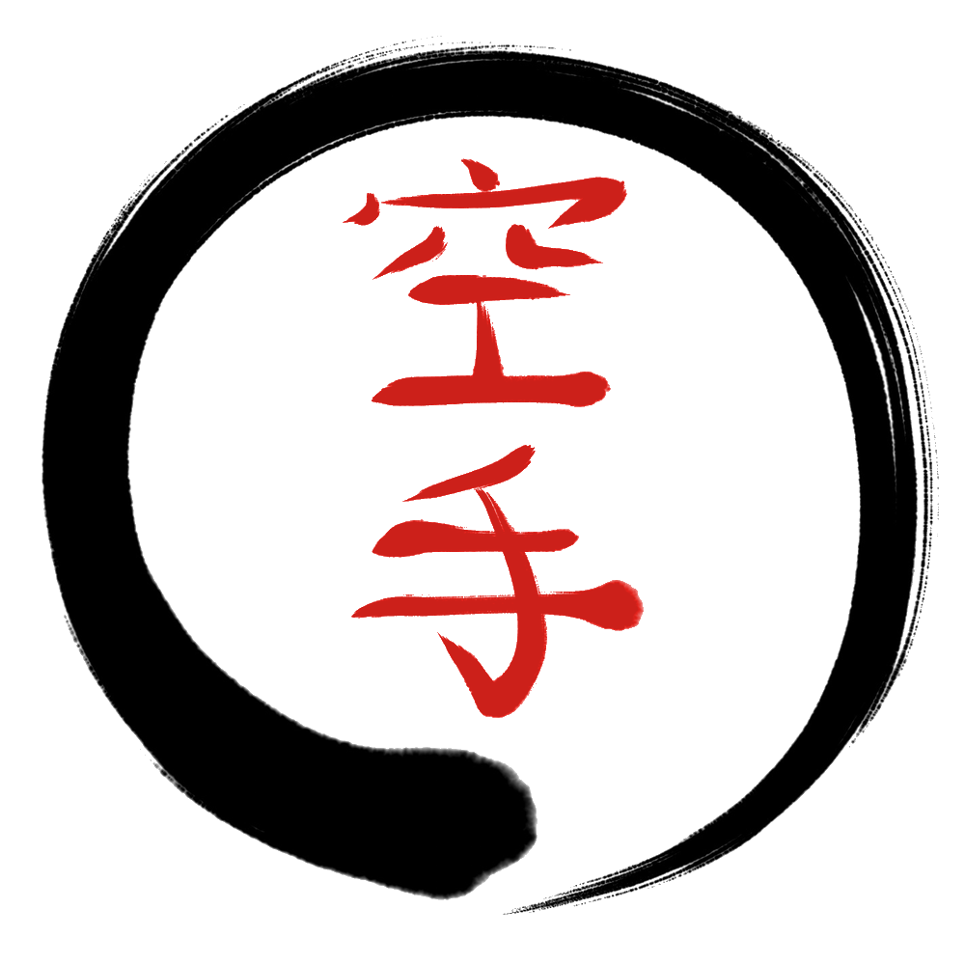 ENSO KARATE
2019 News
Harrisville group returns on the 31st of January at a new venue – Harrisville School of Arts, Queen Street, Harrisville as the Community Hub is closing down. Same day and time as last year - Thursday 5.30-6.30.
Ipswich group will be starting up for 2019 on the 9th of January. We only take a small break over the holidays for this group as we are all homeschoolers and like to keep up our activities over the holidays!! We have some spaces left in the Ipswich group, so if you know of any homeschooled kids who are looking for a new activity for 2019, please tell them about us.
Grading  This December saw our first ever grading with six students achieving their yellow belts (10th kyu). We understand how challenging it can be for many of us to ‘perform’ for gradings, so we take a much gentler approach, tailoring grading to the individual’s needs. Congratulations to Hayley, Hannah, Damara, Hugh, Milla and Ari!!  Harrisville students will be grading early in the new year so keep practicing over the holidays.  We will be holding regular gradings throughout 2019, so if your child missed out on grading in 2018, they will have an opportunity to grade again soon.  Uniform Orders  For those keen for uniforms, we will be taking another order early in the new year and regularly throughout the year. Uniforms are not a requirement but are a tradition within karate and many students do enjoy wearing them.  We wish you and your family a happy and safe holiday break. |  | To make sure you don’t miss out on any news, please follow Enso Karate on Facebook. If you’d like to leave a review on the Facebook page, that would be wonderful as it helps other families considering karate for their child to get a feel for what Enso Karate is all about.  If you’d like to chat with Sensei Leif about your child’s karate training, please feel free to email at karate.ipswich@gmail.com.  And don’t forget our website – ensokarate.net
  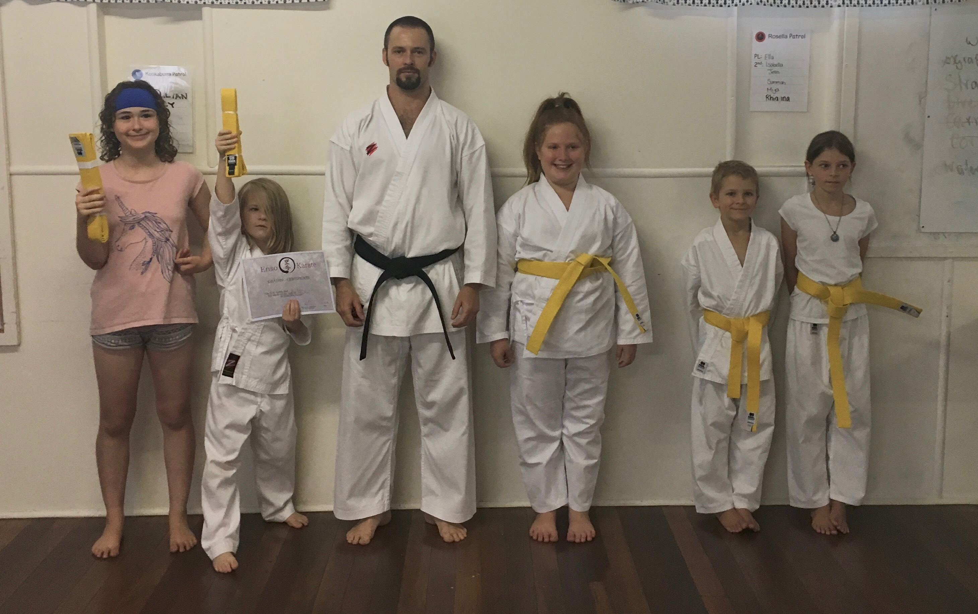
  Congratulations to our new yellow belts!
  Keep in touch

